**PART ONE: What Tools Contributed to Your Team Dynamics?**

Access and review the slides, your notes, and written assignments from the Fall quarter for this course to address the questions below thoughtfully. Note there are **three steps** to this assignment.

**Step 1**: Rate your overall satisfaction with your Practicum Team’s dynamics and outcomes. Check the appropriate box below.

|  |  |
| --- | --- |
| **I am very satisfied with our team’s dynamics and outcomes**  My team was the “dream team.” We worked well together. We had a good, productive conflict which allowed us to have better processes, manage our stakeholders, and achieve exceptional outcomes. |  |
| **I am somewhat satisfied with our team’s dynamics and outcomes.** Overall, we worked well together, but we could have been more effective (e.g., been more efficient, had more “good conflict,” had a more strategic way of managing our stakeholders, and/or better outcomes. | X |
| **I am not satisfied with our team’s dynamics and outcomes.**  My team was a disaster. We had a lot of conflict, and I wish never to repeat that experience. |  |

**Step 2:** Below is a list of activities, concepts, or tools that involved improving team dynamics we discussed in class. For each item in the tables below, address the following in the space provided.

* Describe your understanding of its purpose
* The extent to which you and/or your team utilized it
  + Utilized it well
  + Utilized it somewhat
  + Missed the opportunity to use it
* If you and/or your team utilized it, describe its positive impact on your team’s dynamics.
* If you and/or your team underutilized it, describe the missed opportunity.

|  |  |
| --- | --- |
| **Activity: Building a Paper Tower in Class 1** | |
| Purpose | To see how we work together as a team |
| Extent of Utilization | Utilized when assigning tasks for the first couple weeks |
| Description of Positive Impact or Missed Opportunity | Gave us a good understanding of how we worked together |

|  |  |
| --- | --- |
| **Concept: Listening (3 Levels)** | |
| Purpose | To learn how to listen better to our team |
| Extent of Utilization | High utilization; were able to better understand teammates |
| Description of Positive Impact or Missed Opportunity | Provided positive impact to our team as we all worked more efficiently together as a result of the exercise |
| **Tool: Team Charter** | |
| Purpose | To chart our team journey |
| Extent of Utilization | Somewhat |
| Description of Positive Impact or Missed Opportunity | Could’ve acted more on the problems recorded on our team charter |

|  |  |
| --- | --- |
| **Concept: Learning Style Preferences** | |
| Purpose | To help us understand each other |
| Extent of Utilization | High |
| Description of Positive Impact or Missed Opportunity | We all kept in mind how each person listens. This resulted in a somewhat higher functioning team |

|  |  |
| --- | --- |
| **Concept: Communication Styles** | |
| Purpose | To help us understand each other |
| Extent of Utilization | High |
| Description of Positive Impact or Missed Opportunity | Same as previous answer – we were able to be more efficient based on this exercise |

|  |  |
| --- | --- |
| **Concept: Strengths (Balconies & Basements; Domains)** | |
| Purpose | To help us understand each other more |
| Extent of Utilization | High |
| Description of Positive Impact or Missed Opportunity | Helped us understand where each other fall short and were able to have others compensate for that weakness |

|  |  |
| --- | --- |
| **Concept: Learning Style Preferences** | |
| Purpose | Repeat of first box on page |
| Extent of Utilization | Repeat of first box on page |
| Description of Positive Impact or Missed Opportunity | Repeat of first box on page |

|  |  |
| --- | --- |
| **Concept: Values (What shaped you?)** | |
| Purpose | Again, to help us understand each other |
| Extent of Utilization | High |
| Description of Positive Impact or Missed Opportunity | We took everything on this homework assignment into account when communicating and meeting as a team |

|  |  |
| --- | --- |
| **Concept: Needs (What you need to be at your best)** | |
| Purpose | Again, to help us understand each other |
| Extent of Utilization | High |
| Description of Positive Impact or Missed Opportunity | We used everything we learned in this class to be more mindful of each other’s attributes |

|  |  |
| --- | --- |
| **Concept: Feedback (Team Survey & Team Action Plan)** | |
| Purpose | To help the team be more efficient |
| Extent of Utilization | Low |
| Description of Positive Impact or Missed Opportunity | Missed opportunity as we didn’t really know what we were doing then. This lead to a poor action plan/survey |

**Step 3:** In the space below, list 3-5 insights and lessons learned you want to remember to apply to your Capstone group in the Fall.

|  |
| --- |
| 1. Better project understanding 2. Better role assignment 3. More communication (especially with shareholders) 4. More understanding of teammates strengths and weaknesses 5. Better time management |

**PART TWO: Your Goals & Desired Outcomes for Your Internship**

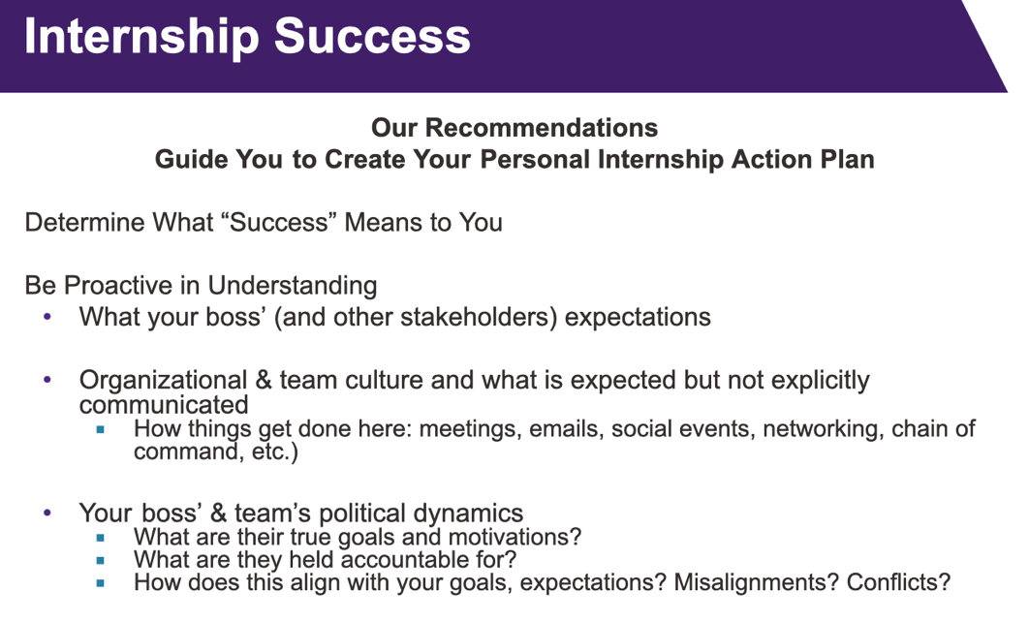

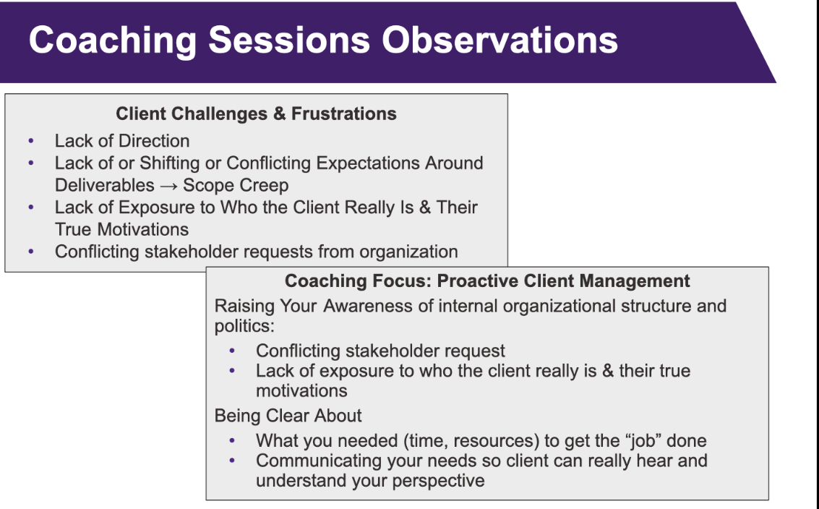

**Step 1:** What are your goals and desired outcomes for your summer internship? Make a list and order by priority. List at least three. Examples:

* Get a job offer from the company
* Learn more about the company and/or industry
* Build relationships/expand my network within the company and/or industry
* Demonstrate my skill set within the company/industry
* Expand my current skills and/or build new technical skills
* Enhance my resume with experience to leverage in future job search
* Other

|  |
| --- |
| 1. Demonstrate my skill set within the company  2. Build relationships/expand my network  3. Enhance my resume with experience to leverage in future job search |

**Step 2**: For each of the goals you listed above, determine a “people-related” action item to help you achieve your goals. Use your Practicum Team Experience regarding client management to inform your action item. Also, please explain why you believe each action item will help you achieve your goal.

*Example:*

*Goal #1: Get a Job Offer*

*Action Item #1: Meet with my boss to ensure I understand their goals for my internship during the summer. If my boss is unclear, I will be proactive by developing plans for myself and then asking my boss if my plans align with their expectations and needs. My Practicum team struggled to get clear direction from our client. As a result, we had to develop our own goals and then show the goals and deliverables to our client for her approval. Creating our own goals and having the client fine-tune them helped us be focused and more efficient and ultimately deliver a final product that met the client’s needs.*

|  |
| --- |
| Goal #1: Demonstrate my skill set within the company  Action Item #1: Work hard on a project that I enjoy. While doing this I want to learn as much as possible so I can get better at my job. I will ensure that I am as productive as I can be every day and will go above and beyond to do the best work I can. Make sure to reach out with questions, even if they’re stupid.  Goal #2: Build relationships/expand my network  Action Item #2: I’ve heard that people set up one on ones with random people at the company. This would be a good starting place as I know no one and would like to get to know people at the company and in general. As a result, I want to develop relationships with people over the summer.  Goal #3: Enhance my resume with experience to leverage in future job search  Action Item #3: This one I think is straight forward, I would like to enhance my resume with an internship. That is a big part of the reason I picked this master’s program. I am excited to get industry experience in the work that I enjoy. I plan on picking the most challenging/interesting project that they have this summer and working hard on it. This will be so I can have something impressive to put on my resume. |

If you like, you can send your responses to yourself in the future using the [Future Me app](https://www.futureme.org/).